**DAILY ONLINE ACTIVITIES SUMMARY**

|  |  |  |  |  |  |  |  |
| --- | --- | --- | --- | --- | --- | --- | --- |
| **Date:** | **31/05/20** | | | | **Name:** | **Deena Muthappa** | |
| **Sem & Sec** | **8th sem, A sec** | | | | **USN:** | **4AL16CS028** | |
| **Online Test Summary** | | | | | | | |
| **Subject** | | **IoT** | | | | | |
| **Max. Marks** | | **20** | | **Score** | | **15** | |
| **Certification Course Summary** | | | | | | | |
| **Course** | **Data and computer communication network** | | | | | | |
| **Certificate Provider** | | | **Udemy** | **Duration** | | | **2hrs** |
| **Coding Challenges** | | | | | | | |
| **Problem Statement: No programs were given** | | | | | | | |
| **Status: Completed** | | | | | | | |
| **Uploaded the report in Github** | | | | **Yes** | | | |
| **If yes Repository name** | | | | **deenamuthappa/Coding-Challenges** | | | |
| **Uploaded the report in slack** | | | | **Yes** | | | |

Online Test Details:

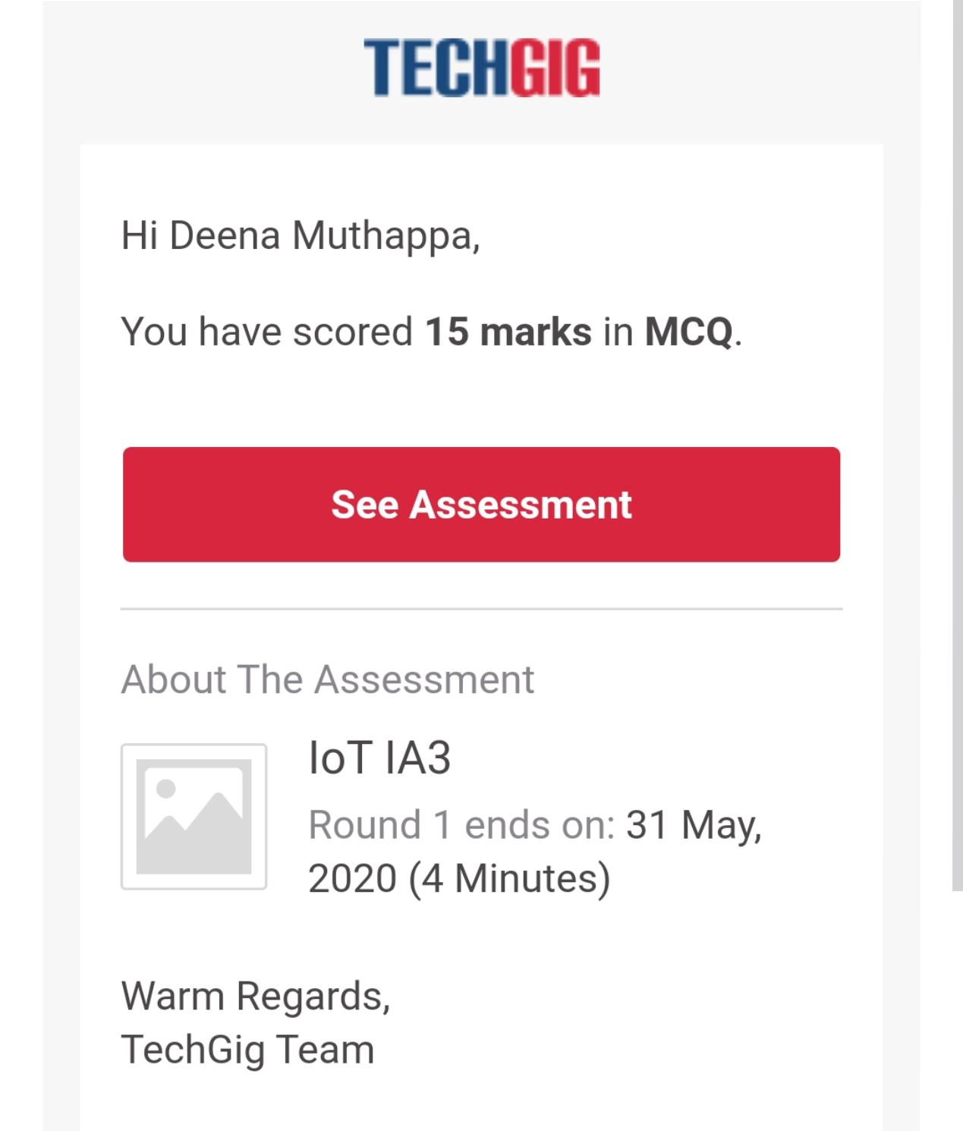

The test was on the subject Internet of Things.

Certification Course Details:

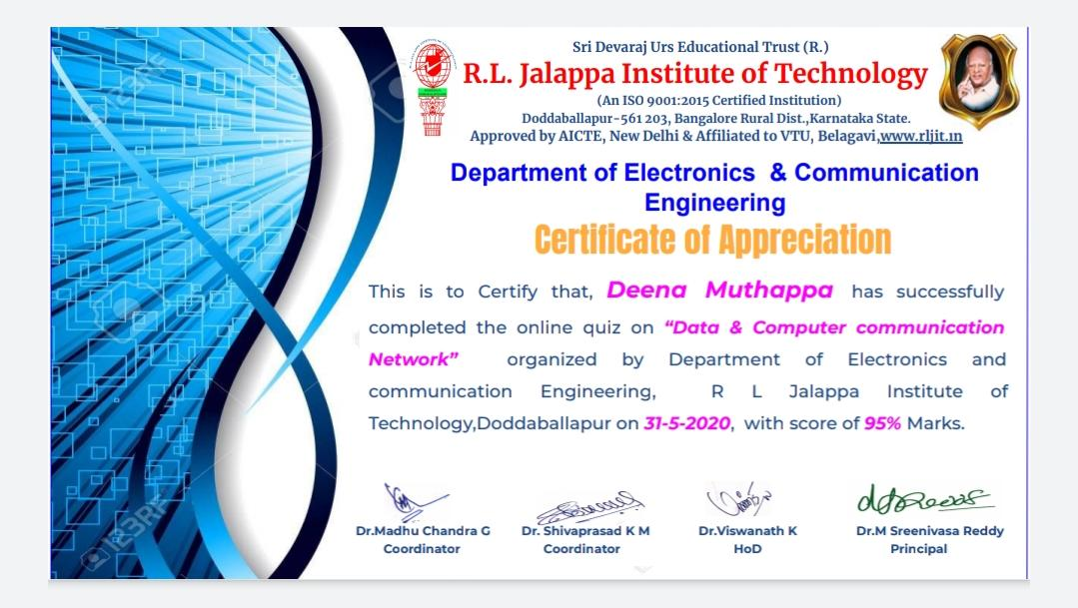

Coding Challenges Details: Not assigned any